
SmartChef AI — Intelligent Recipe Assistant
Introduction to Artificial Intelligence
Jean Merhi
Dana Sakaan
Spring 2026

Table of Contents
1. Problem Description 3
2. AI Approach 3
3. Tools and Technologies Used 5
4. System Design 5
5. Testing and Results 6
6. Ethical and Social Impact 7
7. Challenges Faced 8
8. Future Improvements 8
9. Conclusion 8
Appendix 9

1. Problem Description
Many students and families often struggle to decide what to cook using the ingredients available at home. This problem leads to:
- Food waste
- Time loss
- Decision fatigue
- Difficulty following recipes while cooking
Traditional recipe websites require users to manually search for recipes and read long instructions while cooking. This can be inconvenient when hands are busy or messy.
Proposed Solution
SmartChef AI is an intelligent cooking assistant that uses multiple AI technologies to:
- Detect ingredients from a photo
- Generate a recipe automatically
- Create an image of the final dish
- Read the recipe aloud using voice narration
The system provides a simple and interactive cooking experience while reducing food waste and improving accessibility.

2. AI Approach
The project combines four different Artificial Intelligence capabilities.
2.1 Computer Vision (Ingredient Recognition)
The system uses image classification to recognize food ingredients from camera images.
Technique Used
- Supervised Learning
- Image Classification
Tool Used
- Teachable Machine
Process
The model was trained using several classes:
- Tomato
- Onion
- Egg
- Cheese
- Pasta
For each ingredient, around 30 training images were captured using a webcam from different angles and lighting conditions.
The trained model predicts the ingredient shown by the user.
2.2 Natural Language Processing (Recipe Generation)
After ingredient detection, a generative AI model creates a recipe automatically.
AI Capability
- Natural Language Generation (NLG)
Tool Used
- Chat GPT
Example Prompt
“I have these ingredients detected by my AI: tomato, egg, onion, cheese. Generate a simple recipe with ingredients, quantities, cooking steps, cooking time, and one health tip.”
The AI then generates a complete recipe in less than 200 words.
2.3 AI Image Generation
The generated recipe is transformed into a realistic food image using generative image AI.
AI Capability
- Generative AI
- Text-to-Image Generation
Tools Used
- Gemini Nano Bananna
Example Prompt
“A professional food photography shot of creamy tomato-cheese omelet on a white plate, warm lighting, top-down view, 4K.”
The generated image helps users visualize the final meal.
2.4 Speech Synthesis (Text-to-Speech)
The recipe text is converted into spoken audio so users can listen while cooking.
AI Capability
- Speech Synthesis
- Text-to-Speech (TTS)
Tool Used
- TTS Maker
The generated MP3 file allows hands-free cooking assistance.

3. Tools and Technologies Used
Component | Tool | Purpose
Ingredient Recognition | Teachable Machine | Image classification
Recipe Generation | ChatGPT | AI text generation
Image Generation | Gemini | Food image generation
Voice Narration | TTSMaker | Speech synthesis

4. System Design
4.1 Workflow
User uploads ingredient photo
↓
Teachable Machine detects ingredients
↓
ChatGPT generates recipe
↓
Gemini creates dish image
↓
TTS system converts recipe into audio
↓
User cooks using voice guidance

4.2 Detailed Explanation
Step 1 — Ingredient Detection
The user captures or uploads a food ingredient image. The trained classifier predicts the ingredient category.
Step 2 — Recipe Generation
The detected ingredients are sent to Chat GPT, which creates a recipe including:
- Recipe name
- Ingredients
- Quantities
- Cooking instructions
- Cooking time
- Health tip
Step 3 — Dish Visualization
A text prompt describing the recipe is entered into an Gemini image generator to create a realistic meal image.
Step 4 — Voice Assistance
The generated recipe is converted into audio using TTS software, allowing users to follow instructions hands-free.

5. Testing and Results
Test Case 1
Input Ingredients
- Tomato
- Egg
- Onion
- Cheese
Generated Recipe
Creamy Tomato Cheese Omelet
Ingredients (1 serving):
- 2 eggs
- 1 medium tomato, chopped
- 1/2 onion, sliced
- 30–40 g cheese (cheddar or any melting cheese)
- 1 tbsp olive oil (optional but recommended)
- Salt & pepper to taste

Instructions:
- Heat olive oil in a pan over medium heat.
- Add sliced onion and cook for 2–3 minutes until soft.
- Add chopped tomato and cook for another 3–4 minutes until slightly saucy.
- Crack eggs directly into the pan. Season with salt and pepper.
- Cook until egg whites are set but yolks are still soft (or cook longer if preferred).
- Sprinkle cheese on top and cover for 1–2 minutes until melted.
- Serve hot.
Cooking time: ~10–12 minutes
Health tip:
Use less salt and choose low-fat cheese to reduce sodium and saturated fat while keeping the dish nutritious and protein-rich.
AI-Generated Dish Images
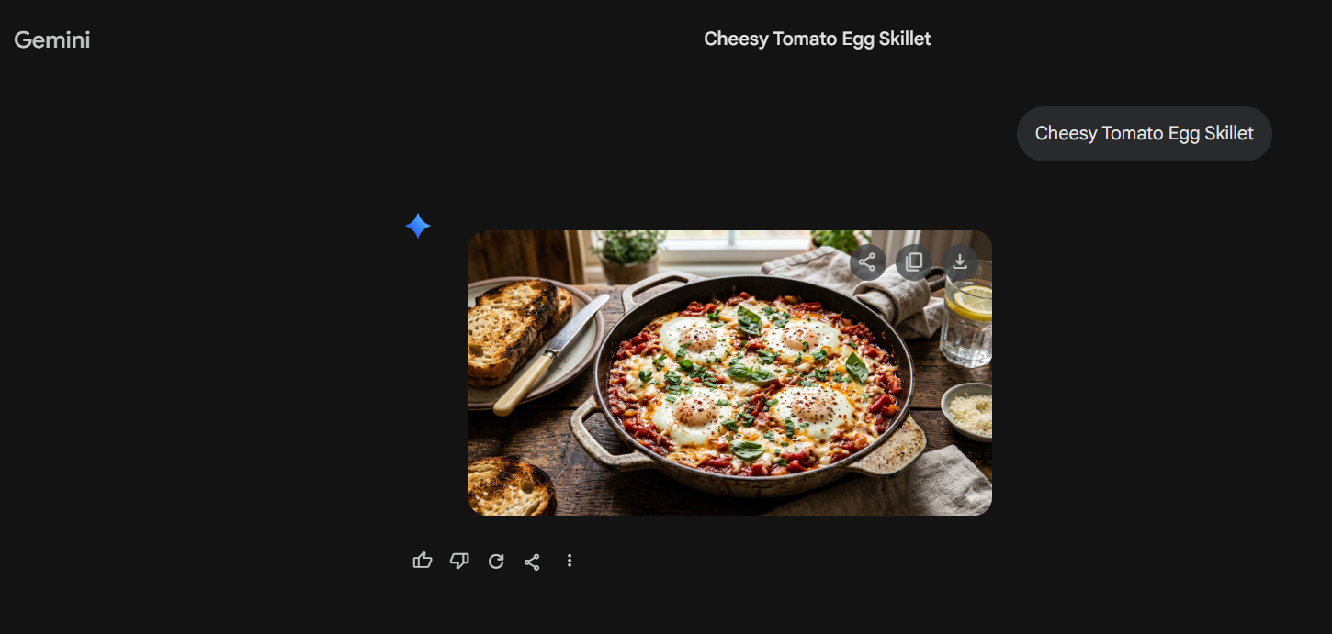
TTS Audio(submitted with the images on github)
Result
The AI successfully generated:
- A valid recipe
- A realistic food image
- A voice narration audio file

6. Ethical and Social Impact
Positive Impacts
Reducing Food Waste
The system encourages users to use ingredients already available at home.
Accessibility
Voice narration helps users cook hands-free and supports visually impaired users.
Convenience
The AI saves time by automatically generating recipes.
Ethical Concerns
Privacy
Users upload photos that may contain personal background information.
AI Bias
Recipe suggestions may favor certain cultures or cuisines more than others.
Health Risks
AI-generated recipes may not account for:
- Allergies
- Dietary restrictions
- Medical conditions
Users should verify ingredients before cooking.

7. Challenges Faced
During development, several challenges appeared:
- Difficulty collecting enough training images
- Incorrect ingredient predictions under poor lighting
- AI sometimes generated unrealistic recipes
- Some generated images did not perfectly match the recipe
These issues were reduced by improving prompts and training data quality.

8. Future Improvements
Future versions of SmartChef AI may include:
- Mobile application integration
- Real-time camera detection
- Barcode scanning
- Nutritional analysis
- Allergy warnings
- Multi-language support
- Voice interaction chatbot

9. Conclusion
SmartChef AI successfully combines multiple Artificial Intelligence technologies into one practical application.
The project demonstrates:
- Computer Vision
- Natural Language Processing
- Generative AI
- Speech Synthesis
The system helps users reduce food waste, save time, and enjoy a smarter cooking experience. The project also shows how different AI technologies can work together to solve real-life problems in a simple and effective way.

Appendix
- Teachable Machine training interface
- Ingredient detection results
- ChatGPT recipe generation
- Gemini food image
- Text-to-speech interface
- Test case outputs

